Socialization of Room Division Management in Enhancing the Career Readiness of SMKN 10 Batam Students within the Tourism Sector in the Digital Era

Supardi^{1*}, Arina Luthfini Lubis², Andri Wibowo³, Yudha Wardhani⁴, Zahara Fatimah⁵, Fidya Farasalsabila⁶, Bintang Cendekia⁷
Manajemen Devisi Kamar, Politeknik Pariwisata Batam, Indonesia^{1,2,3,4,5,7}
Sistem Informasi, Institut Teknologi Batam, Indonesia⁶
e-mail: supardi@btp.ac.id¹*, a.luthfinilubis@gmail.com², andreewibowo.pku85@gmail.com³, yudha@btp.ac.id⁴, zaravirgo2579@gmail.com⁵, fidya@iteba.ac.id⁶, bintangcendikiawan24@gmail.com⁷

Abstract
This Community Service (PKM) initiative aims to enhance student career readiness through the socialization and fundamental training of hospitality management at SMK Negeri 10 Batam. The program is localized in response to the limited student understanding of sectoral career prospects and deficient digital literacy regarding the use of social media for career exploration. Conducted in March 2026 with 120 participants across grades X, XI, and XII, the methodology employed a holistic, interactive, and applied approach, comprising material dissemination, digital practice, open discussions, and pre-test/post-test evaluations. The results indicate a significant improvement in students' comprehension of hospitality management, with an average increase exceeding 60%. Furthermore, this initiative fostered career motivation and awareness in the digital era and established a framework for sustainable collaboration between academia and educational institutions to align graduates' competencies with the demands of the Business and Industrial World (DUDI).
Keywords: Community Service, Hospitality Management, Career Readiness, Digital Tourism, Social Media Literacy, Vocational High School Students

INTRODUCTION
The development of Indonesia's tourism industry exhibits an increasingly positive and dynamic trend, aligned with the acceleration of information and communication technology in the digital era (Silubun et al., 2026). As a strategic destination in the Riau Islands, Batam City possesses significant potential in marine, cultural, and retail tourism. This condition necessitates that the younger generation, including vocational students, acquire a fundamental understanding of hospitality management as a primary basis for identifying career opportunities within the sector (Widari Nasution et al., 2025).
Knowledge of tourism is not limited to travel activities but encompasses a comprehensive understanding of excellent service, hotel operational management, destination governance, and professional ethics (Fakhriani et al., 2025). Through the socialization of basic hospitality management, students can gain deeper insights into industry standards and required competencies. This is crucial for cultivating a professional mindset from an early stage, ensuring that students possess a structured and competitive career orientation (Silitonga et al., 2023).
Furthermore, increasing interest in the tourism sector must be encouraged through comprehensive education. Many students have yet to fully comprehend that the tourism industry offers a wide array of career paths, such as hospitality, travel agencies, event management, tour guiding, destination management, and tourism-based entrepreneurship (UNESCO strategy, 2022). By providing a thorough understanding of hospitality management, students will be able to identify prospective career trajectories and extensive self-development opportunities on local, national, and international scales (Rafah, 2024).
The contemporary tourism industry is also heavily influenced by digital transformation. The implementation of online reservation systems, travel applications, and the integration of information technology in operational management have become fundamental requirements (Kindzule-Millere & Zeverte-Rivza, 2022). Consequently, student career readiness must be aligned with digital advancements. A basic understanding of hospitality management combined with digital literacy is projected to enhance student competitiveness in both entering the labor market and pursuing further education in the field (Rafah, 2024).
On the other hand, social media plays a strategic role as both an information source and a tool for tourism promotion. Digital platforms serve not only as entertainment media but also as instruments for education and destination marketing (Hudatil Atkiyan & Rizki Kurniawan, 2025). As digital natives, the younger generation must be equipped with the ability to utilize social media productively, both for building personal branding and as a tourism promotion tool (Sutrisno et al., 2023). Thus, this socialization and basic training initiative is expected to enhance the career readiness of SMKN 10 Batam students while fostering relevant interest and competence within the tourism sector.
- Limited Awareness of Tourism Management among Students
At the secondary education level, students often lack an adequate understanding of tourism and hospitality management concepts. Most students perceive tourism merely as a recreational activity or travel, failing to comprehend the intricate aspects of service management, operational procedures, destination marketing, and the standards of excellent service that form the industry's core. This lack of comprehension prevents students from recognizing tourism as a structured and promising professional field of study and career path.
- Impact of Information Scarcity on Career Perception
The lack of directed access to information regarding the tourism industry results in low student awareness of career opportunities within the sector. Information received by students is frequently generic and unsystematic, depriving them of a comprehensive overview of career hierarchies, required competencies, and self-development opportunities. Consequently, there is a diminished interest among students in pursuing tourism for higher education or future employment.
- Pre-test Findings on Tourism Career Prospects
Initial pre-test results conducted prior to the program indicate that the majority of students are unable to specifically identify various professions in tourism, such as hotel managers, front office personnel, tour planners, event organizers, digital tourism marketers, or destination managers. This reveals a significant gap between the rapidly growing potential of the tourism industry and the limited career literacy of students. These preliminary data serve as a crucial baseline for implementing this Community Service (PKM) as an educational intervention.
- Digital Advancement vs. Fragmented Educational Content
While rapid technological advancements have expanded access to information, social media content remains predominantly focused on entertainment rather than career education. Content concerning hospitality management, digital reservation systems, destination management, and tourism marketing strategies is relatively scarce and rarely curated for vocational students. As a result, the potential of digital media as a tool for career literacy has not been optimally utilized.
- Design of Digital-Based Tourism Information Literacy Program
This Community Service (PKM) program is designed to enhance students' tourism literacy through an educational and applied digital approach. Activities include the socialization of hospitality management, introduction to career prospects, the use of social media for tourism promotion, exposure to tourism information systems (online reservations and digital branding), and the reinforcement of soft skills such as communication and grooming. This approach empowers students to transition from being passive social media users to utilizing digital platforms for career development.
- Early Observation of Career Opportunities
For students in their initial semesters, this initiative serves as a foundational step in identifying and observing various career opportunities in tourism. Through material exposure, case studies, and interactive discussions, students can begin formulating long-term career plans, understanding relevant educational pathways, and preparing necessary competencies early on. This strategy fosters career awareness before they enter the phase of selecting majors or pursuing higher education.
SMKN 10 Batu Besar, Nongsa District, is located in Batam City, Riau Islands Province, which is geographically situated in a strategic border area near Singapore and Malaysia. Batam is known as both an industrial city and a city with burgeoning tourism potential, particularly in the marine tourism, resort, and retail sectors (Silitonga et al., 2023). This strategic geographical position provides significant opportunities for the graduates of this school to engage in the local and regional tourism industry; thus, it is imperative for students to have career readiness that aligns with the region's potential (Fakhriani et al., 2025).
The school administration provides positive support for the implementation of this PKM as part of strengthening career guidance programs and enhancing student insights. This support is manifested through the provision of venues, coordination with career counselors and homeroom teachers, and the active participation of students in the socialization and training activities. The synergy between the Batam Tourism Polytechnic PKM team and the school is a vital factor in ensuring the activity runs effectively and provides a sustainable impact.
This PKM activity provides direct benefits to participants in the form of increased knowledge of hospitality management, an understanding of tourism career prospects, and basic service and digital literacy skills. Furthermore, students gain motivation and a realistic view of job opportunities relevant to current industry developments. With this preparation, students are expected to have better confidence and readiness in planning their future careers.
The expected output of this PKM activity is the development of students who possess tourism career literacy and initial readiness to enter the Business and Industrial World (DUDI). Additionally, this activity is expected to open collaborative opportunities between the school and tourism industry players, such as hotels, travel agents, and destination managers in Batam. Through a broader collaborative network, students can gain access to internships, industrial visits, and sustainable competency development opportunities.
COMMUNITY OVERVIEW
SMK Negeri 10 Batam is a prominent vocational high school located in the Batu Besar area of the Nongsa District, Batam City a region strategically positioned as a hub for international tourism, high-end resorts, and transit gateways in the Riau Islands. As a vocational institution, the school plays a vital role in preparing the local workforce to meet the demands of the tourism and hospitality sectors, which are the primary economic drivers of the surrounding area. Its proximity to Singapore and Malaysia further enhances its strategic importance in producing graduates who possess both technical competence and international hospitality standards.
SMK Negeri 10 Batam was selected as the partner for this Community Service (PKM) activity for several critical reasons. First, the school is a key provider of vocational talent in Nongsa, a district characterized by rapid growth in digital tourism and hospitality infrastructure. Ensuring that its students are equipped with career readiness is essential for maintaining a sustainable talent pipeline for the industry. Second, based on preliminary observations and discussions with the school’s leadership, it was identified that while students possess basic vocational skills, there is a significant need for a more structured understanding of hospitality management and career prospects within the digital era. Many students remain unaware of the diverse professional trajectories available beyond basic operational roles. Third, the school has demonstrated a progressive commitment to enhancing its career guidance programs through academic collaboration. The management actively seeks external expertise to bridge the gap between the classroom curriculum and the dynamic requirements of the Business and Industrial World (DUDI).
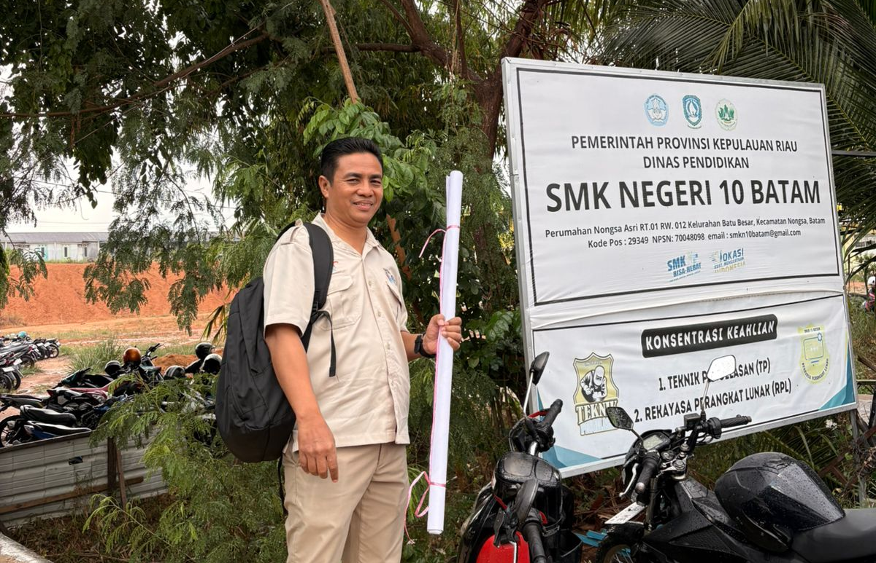
Figure 1. Location of Community Service at SMKN 10 Batam

Furthermore, the implementation of the PKM activity at this school offers substantial added value by integrating theoretical management concepts with practical digital literacy. By engaging with students in their own learning environment, the program fosters a contextual and applicable educational experience that aligns with modern vocational education standards. Consequently, SMK Negeri 10 Batam serves as an ideal partner that shares a common vision in building a robust educational ecosystem and fostering professional career readiness in the digital hospitality landscape.

METHODOLOGY
This Community Service (PKM) activity was conducted in March 2026 at SMK Negeri 10 Batam, located in the Nongsa Asri Housing Complex, Batu Besar, Nongsa District, Batam City. The implementation was centered in the school's multipurpose hall, which served as a representative venue for socialization, presentations, and digital-based training sessions. The selection of this location considered participant accessibility and the availability of supporting facilities such as projectors, internet connectivity, and group discussion spaces. The multipurpose hall functioned as the hub for socialization and training, facilitating direct interaction between the organizing team and the participants.
The participants consisted of 120 students from grades X, XI, and XII. This multi-level involvement aimed to establish career literacy from an early stage for junior students while strengthening work readiness and further study orientation for senior students. The characteristics of the participants as vocational high school students, who are inherently vocationally oriented, served as the foundation for designing more applied and contextual methods. This PKM was designed with a holistic, interactive, and applied approach, tailored to the characteristics of vocational students who are more responsive to practical learning methods. The holistic approach was achieved by integrating aspects of knowledge, skills, and professional attitudes. The interactive approach was implemented through two-way discussions, Q&A sessions, and case studies, while the applied approach was realized through direct practice in utilizing social media as a tool for tourism exploration and promotion. Students did not merely receive theoretical material but directly practiced using social media to explore information and promote tourism.
The primary activities included presentations on career introductions in the tourism industry, explaining various professions such as hospitality, travel agencies, event organizers, digital tourism marketing, and destination management. Furthermore, students were guided to understand how to explore the tourism sector more deeply through social media, including techniques for seeking reliable information, building personal branding, and identifying industry trends through digital platforms.
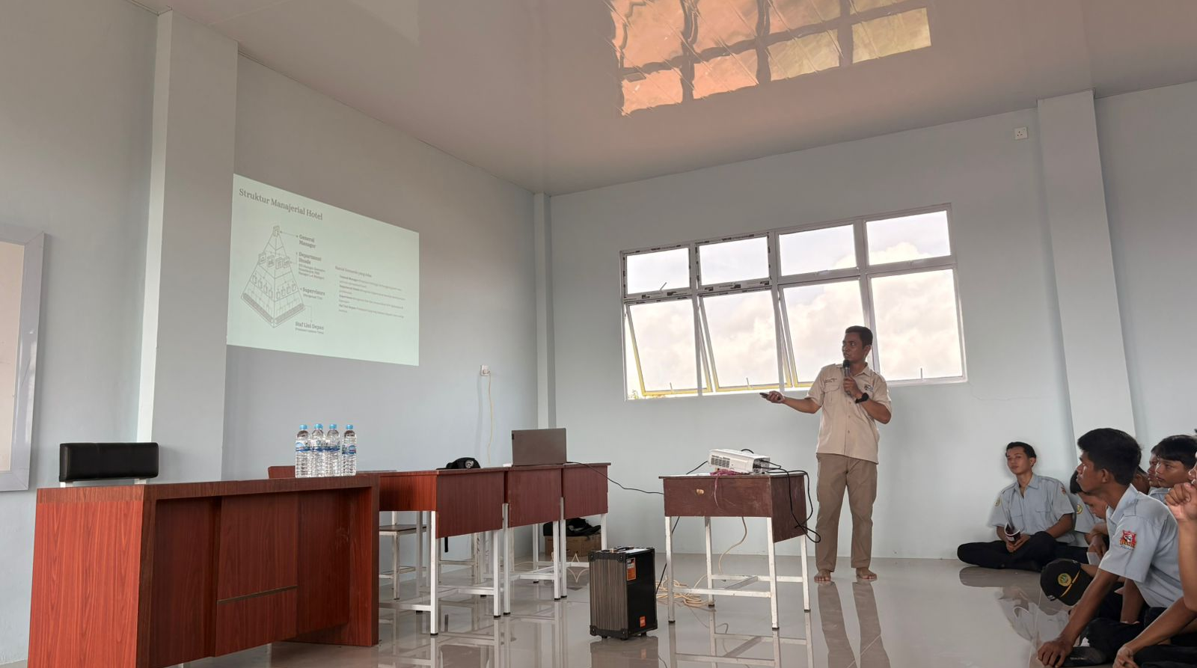
Figure 2. Presentation of Material on Digital Hospitality Management
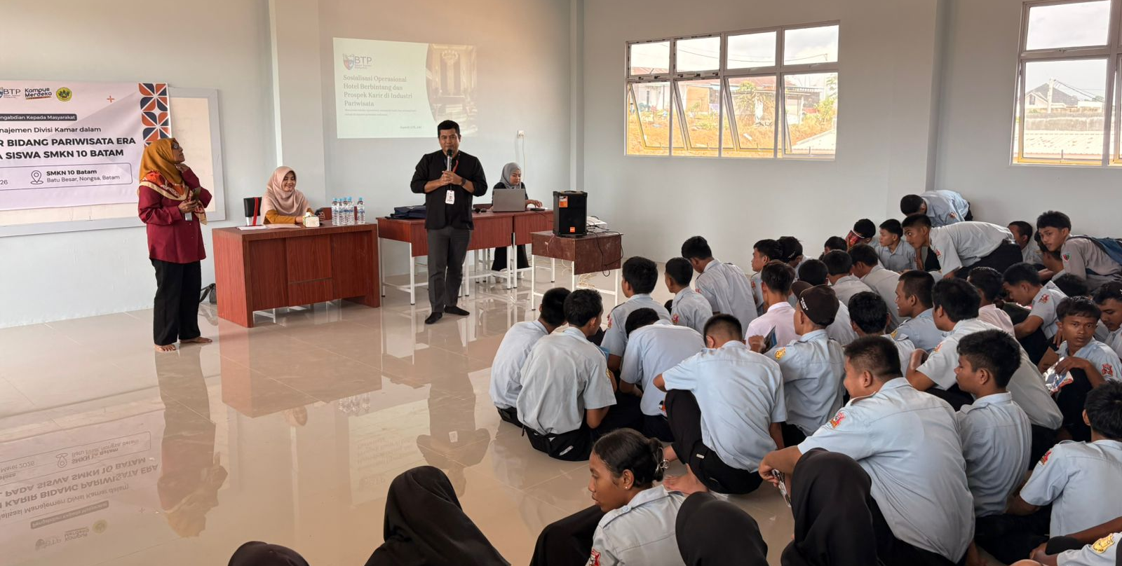
Figure 3. Presentation of Material on Tourism Career Prospects

The training method employed a collaborative model between academics (lecturers), university students, and vocational students. Lecturers served as primary resource persons providing conceptual reinforcement and strategic direction, while university students acted as accompanying facilitators in practical sessions. University students provided technical assistance in digital practice, while vocational students became active participants directly involved in the learning process. This collaborative model created a learning atmosphere that was more relatable, communicative, and aligned with the character of the younger generation.
Training priorities focused on the direct use of digital social media as a means of literacy and tourism career exploration. Students were encouraged to access platforms such as Instagram, TikTok, and YouTube to identify educational tourism content, analyze destination promotion strategies, and document training activities through photos and simple digital content. These activities were conducted on-site with technical supervision.
In conclusion, an open discussion was held to provide students with the opportunity to express their questions, interests, and curiosity regarding the world of tourism. This forum served as a means of reflection as well as an evaluation of the students' understanding of the materials presented. Through this method, it is expected that there will be an increase in tourism career literacy and student readiness in facing industrial challenges in the digital era. This discussion also functioned as a space for reflection and a means to identify further information needs that can be developed in subsequent mentoring programs.
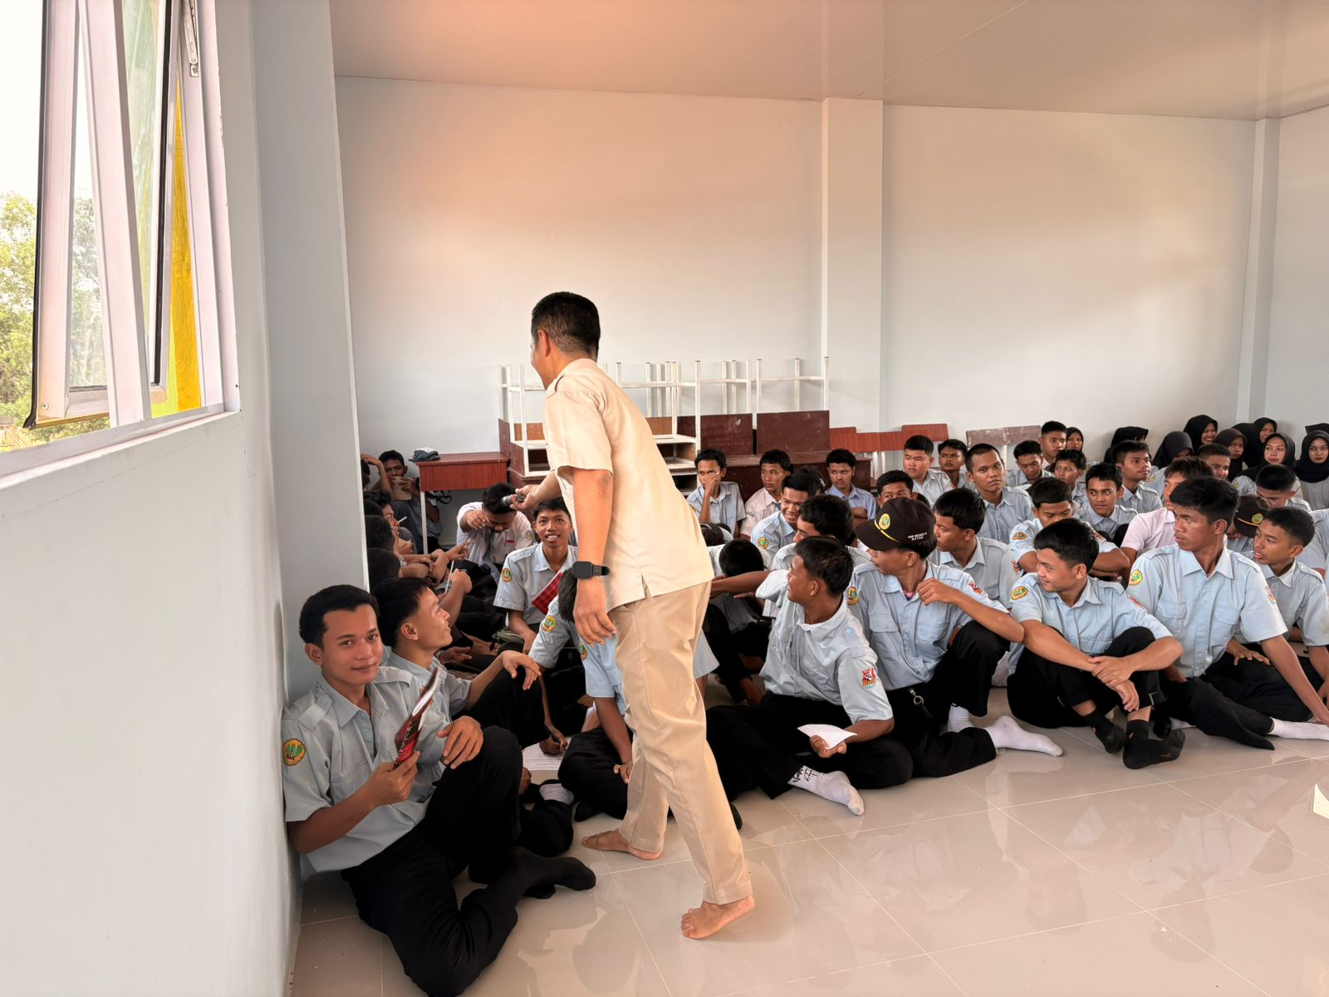
Figure 4. Q&A and Discussion Session

SUSTAINABLE RESULT AND POTENTIAL
The Community Service (PKM) activity conducted at SMKN 10 Batam proceeded through a systematic series of processes, encompassing the planning, implementation, and post-activity phases. Overall, the initiative yielded positive results in enhancing students' tourism literacy and career readiness. The structured process provided a tangible impact in terms of both knowledge acquisition and student motivation toward the tourism sector.
In the initial phase, the activity focused on the comprehensive preparation of a proposal, covering the background, objectives, methodology, and performance indicators. This proposal served as both an academic and administrative foundation to ensure the activity had clear and measurable directions. Meticulous planning was a key factor in the success of this PKM, as the entire team possessed a thorough understanding of their respective roles and target outcomes.
The subsequent phase involved field technical coordination and administrative liaison with the school. Coordination included scheduling, ensuring the readiness of the multipurpose hall, finalizing participant numbers, and confirming the availability of supporting facilities such as LCD projectors and internet access. Administratively, licensing documents and correspondence were prepared to ensure the activity adhered to institutional procedures.
During the implementation, Mr. Supardi served as the primary communicator with the school and the lead resource person, delivering material on career introductions in tourism. The content covered an overview of the tourism industry, hospitality management, and employment opportunities in hotels, travel agencies, and event organizations, as well as international career prospects. The communicative delivery of this material effectively generated student enthusiasm for the tourism sector. Fidya Farasalsabila was responsible for preparing essential documentation, including the proposal and administrative support, as well as documenting the event. Furthermore, she served as the second resource person, presenting on digital tourism marketing. This session explained the utilization of social media as a tool for destination promotion and personal branding in the digital era, providing students with a new perspective on the importance of digital literacy in supporting tourism careers. Andri Wibowo delivered experience-based material regarding overseas hotel internships. This presentation provided concrete inspiration to students regarding international employment opportunities in the hospitality sector. Such real-world narratives enhanced student motivation and broadened their insights into global labor standards within the hotel industry. Zahara Fatimah served as the moderator, guiding the discussion in an active and conducive manner. The interactive session was conducted in a warm and informal atmosphere, ensuring students felt comfortable asking questions and expressing opinions. Agung Edy Wibowo, alongside other faculty members, provided relevant and contextual responses to various student inquiries, particularly concerning educational pathways and necessary competencies.
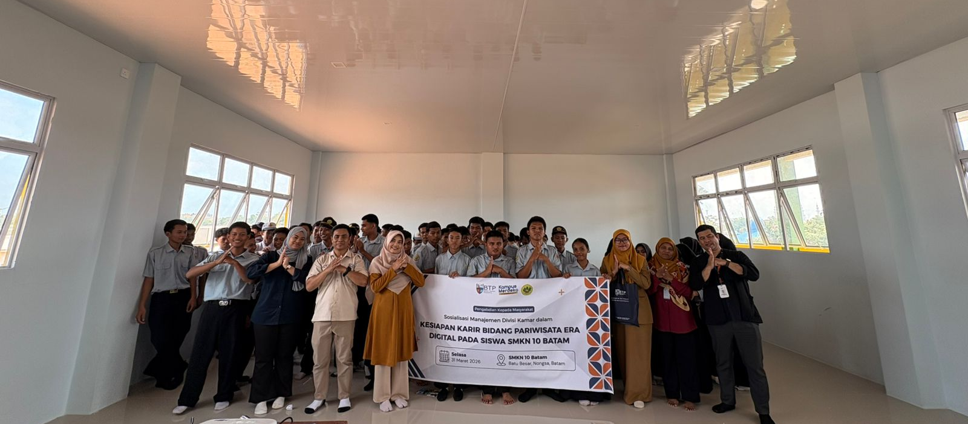
Figure 5. Group Photo Session

Participating university students also shared their academic experiences in tourism and their field work placements (PKL) abroad. These testimonials provided a realistic depiction of the degree process, challenges, and opportunities available should students choose to pursue tourism seriously. The involvement of university students made the activity more relatable to the secondary school students.
From an evaluative standpoint, pre-test results indicated that the majority of students lacked a comprehensive understanding of various professions within the tourism field. Following the socialization and training, post-test results showed a significant increase in student comprehension regarding career prospects, hospitality management, and the use of social media for tourism promotion. This assessment was conducted by comparing average scores before and after the training.
Quantitatively, there was an increase in tourism career prospect comprehension of approximately 60–75% compared to the pre-activity baseline. While the pre-test showed only about 30% of students could identify more than three types of tourism professions, the post-test results rose to over 80% of students being able to explain various career opportunities and the required competencies. This demonstrates that the PKM activity delivered a tangible educational impact.

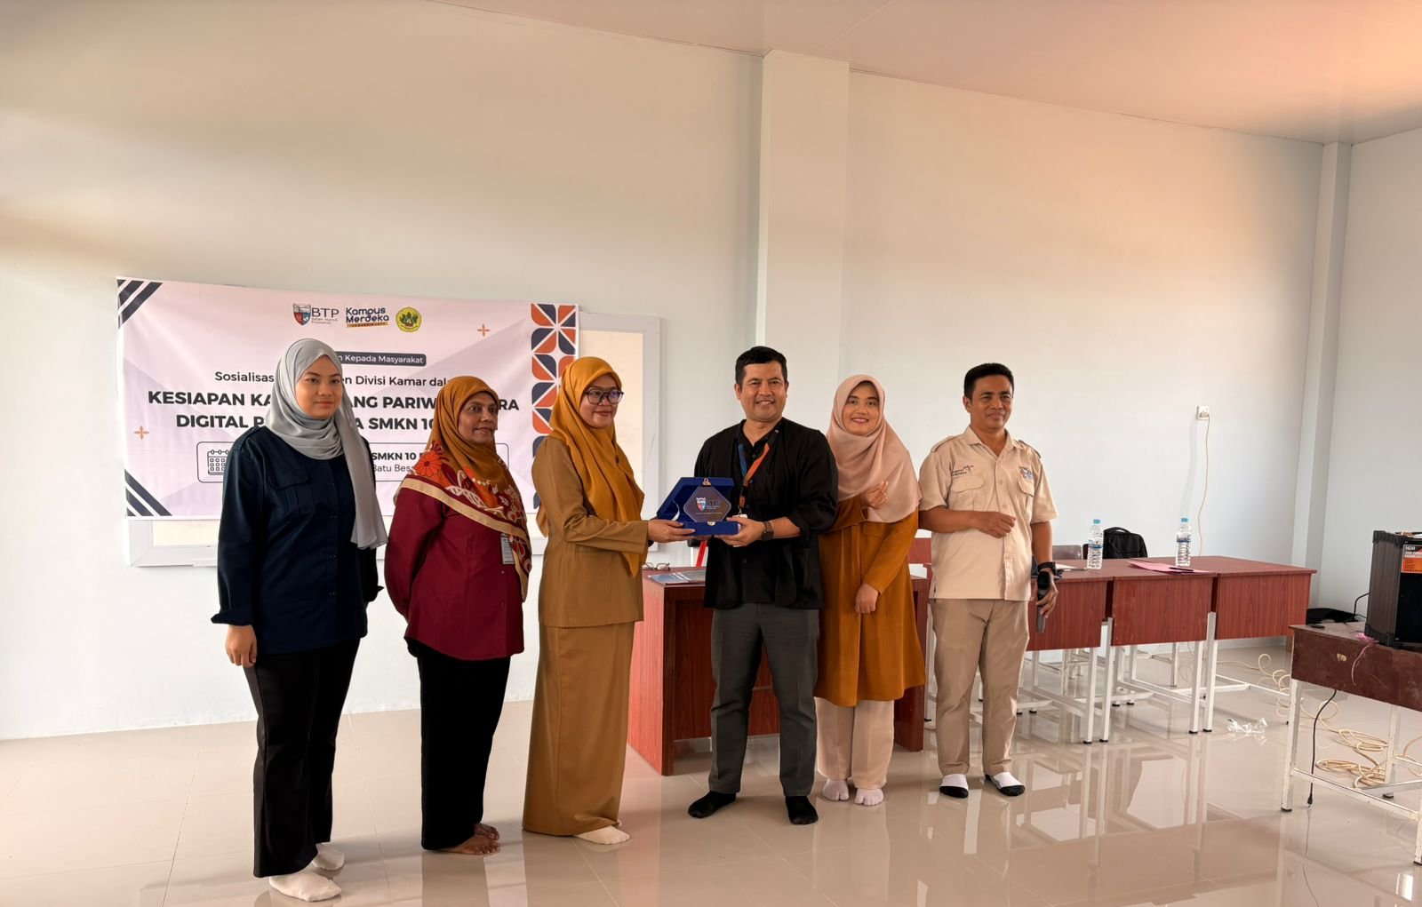
Figure 7. Presentation of Plaque and Certificates of Appreciation

Another positive outcome was the increased motivation among students to consider tourism as a choice for their future careers and further studies. Students also expressed interest in participating in internship programs, advanced training, and establishing communication with the industry. Thus, the activity not only enhanced knowledge but also built career awareness and readiness to face the challenges of the tourism industry in the digital era.

CONCLUSION
The Community Service (PKM) activity conducted at SMKN 10 Batam focuses on the socialization and fundamental training of hospitality management, with a primary emphasis on the introduction and exploration of careers within the tourism sector. This focus is highly relevant given the limited understanding among students regarding job prospects in the tourism industry, particularly within the context of digital-based industrial developments. Through a systematic, interactive, and applied approach, this initiative provides broader insights into career opportunities, required competencies, and the significance of digital literacy in supporting workforce readiness.
The results of the socialization indicate an increase in students' comprehension and motivation toward the tourism industry. Students gained not only knowledge regarding various professions within the hospitality sector but also an understanding of the educational pathways and skills that must be prepared from an early stage. This activity is expected to foster career awareness and cultivate a professional mindset among students as a foundation for engaging with the Business and Industrial World (DUDI).
Beyond providing a direct impact on participants, this PKM initiative establishes opportunities for sustainable collaboration between the academic team and the school. This synergy can be further developed through advanced training, industrial visits, internship programs, or thematic seminars that support the strengthening of student competencies. Continuous collaboration will reinforce the school's function as a vocational educational institution that is responsive to industry demands.
Overall, this activity serves as an initial step in building a harmonious educational ecosystem between academia and SMKN 10 Batam. A robust ecosystem is characterized by open communication, institutional support, and a shared commitment to enhancing human resource quality in the tourism field. Through solid cooperation, it is anticipated that the program will produce graduates who are competent, adaptive to digital developments, and prepared to compete at both local and international levels.

SUGGESTION
Based on the results of the Community Service (PKM) activities at SMKN 10 Batam, it is recommended that similar socialization and training initiatives be implemented sustainably in the future. One-off programs should ideally be developed into routine agendas or periodic mentoring programs to optimize their impact and foster continuous career readiness among students. The sustainability of such programs would also allow for a broader participant reach and a more in-depth exploration of the subject matter.
Furthermore, it is essential for the school administration to consistently provide opportunities and facilities for students to acquire career knowledge and insights before entering the workforce. Early preparation will enable students to develop more mature career planning, understand the competencies required by the industry, and enhance their confidence in navigating job competition. The integration of career socialization activities with counseling programs and soft skills reinforcement represents a strategic institutional step.
Additionally, the cooperation established through the Memorandum of Understanding (MoU) should transcend administrative formalities and proceed toward concrete implementation. Such implementation may take the form of advanced training, industrial internship programs, field visits, joint seminars, or subsequent research and service collaborations. Consequently, the partnership between academia and SMKN 10 Batam can evolve into a productive relationship that provides tangible benefits for the enhancement of human resource quality in the tourism sector.

REFERENCES
Fakhriani, H. M., Firnanda, A. A. P., Putri, A. S., Arini, A., Rafiffalah, M. A., & Alexandro, A. G. (2025). Impact Of Facilities, Services And Sapta Pesona On Tourist Satisfaction At Kiki Beach Resort Batam. Jurnal Kepariwisataan, 24(1), 48–62. https://doi.org/10.52352/jpar.v24i1.1658
Hudatil Atkiyan, F., & Rizki Kurniawan, P. (2025). Kesiapan Digitalisasi Umkm Perhotelan Non Bintang Di Nusa Tenggara Barat Dalam Era Ekonomi Digital.
Kindzule-Millere, I., & Zeverte-Rivza, S. (2022). Digital transformation in tourism: opportunities and challenges. 476–486. https://doi.org/10.22616/ESRD.2022.56.047
Rafah, A. (2024). Soft skills and graduate employability: Insights and research model.
Silitonga, F., Wibowo, A. E., Siska Amelia Maldin, Baktivillo Sianipar, & Mohamad Nur Afriliandi Nasution. (2023). PENGEMBANGAN OBJEK WISATA SEBAGAI INVESTASI MASYARAKAT DI PULAU LANCE BATAM. JURNAL KEKER WISATA, 1(1), 1–11. https://doi.org/10.59193/jkw.v1i1.93
Silubun, H. C. A., Mappanyompa, Agustiani, A., Fussalam, Y. E., Farasalsabila, F., Kogoya, T., Desmelinda, E., Al Azhar, Burhan, R. M., & Syamsuddin, S. (2026). Deep Learning dalam Pendidikan: Konsep, Aplikasi, dan Transformasi Pembelajaran.
Sutrisno, E. Y., Choliq Hidayat, A., & Sutanto, A. (2023). Pemanfaatan E-Commerce Dan Property Management System Dalam Kegiatan Bisnis Perhotelan Di Era Revolusi Industri 4.0 The Use Of E-Commerce And Property Management Systems For Hotel Business Activities In The 4.0 Industrial Era.
UNESCO strategy. (2022). Transforming Technical and Vocational Education and Training for successful and just transitions. http://www.unesco.org/open-access/terms-use-ccbysa-en
Widari Nasution, N., Eka Candra, J., Farasalsabila, F., Reza, W., Kurnia, O., & Trinaldo Simatupang, D. (2025). Pelatihan dasar pemrograman untuk membangkitkan minat siswa pada dunia pemrograman di SMA Kartini Batam. https://smakartinibatam.sch.id/

